

NATIONAL UNIVERSITY OF TECHNOLOGY
(Department of Computer Science)
CS161– Database Systems
Instructor: miss Faiza Khan
Name: Bisma Fatima
Roll no: f24605036

LAB TASK 09
Create database in Microsoft SQL Server Management Studio.
- Connection to server
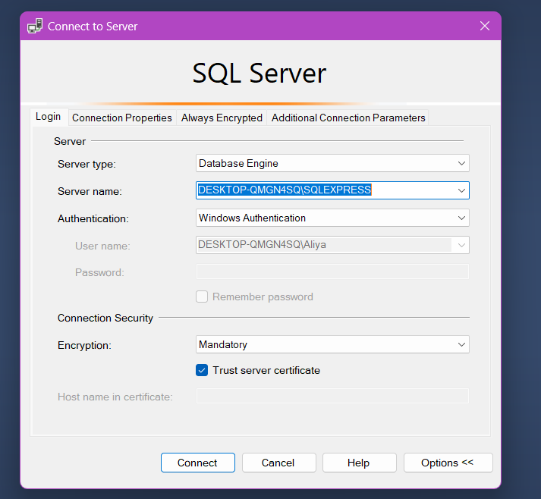
- Database Creation
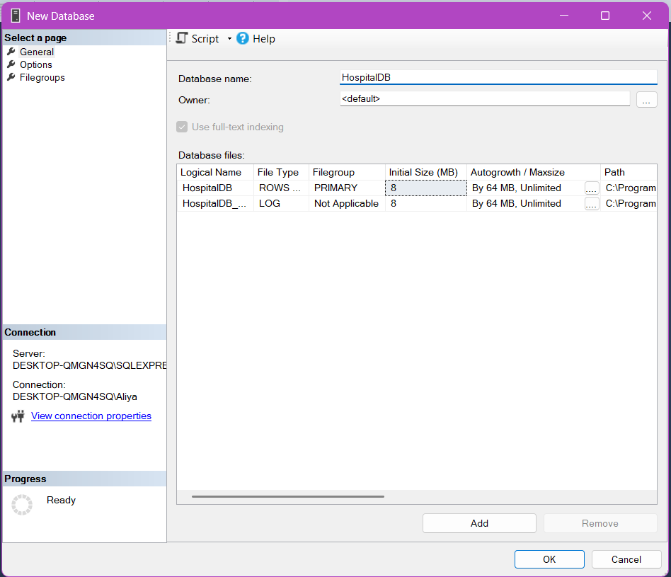

TASK 1 TABLES CREATION
SYNTAX TABLE CREATION :
CREATE TABLE tablename (
column1 datatype,
column2 datatype,
column3 datatype,
....
);
- Patient Table
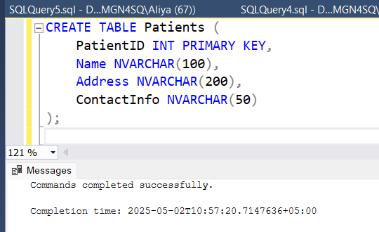
- Medical Staff
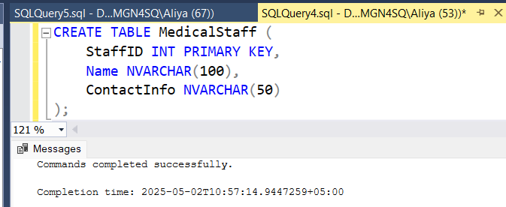
- Treatment Table
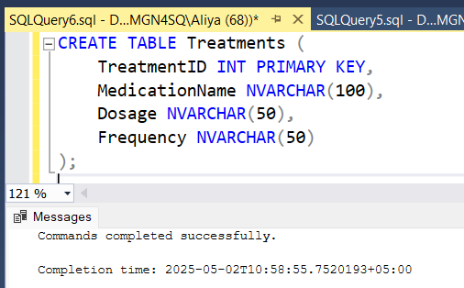
- Medical Record table
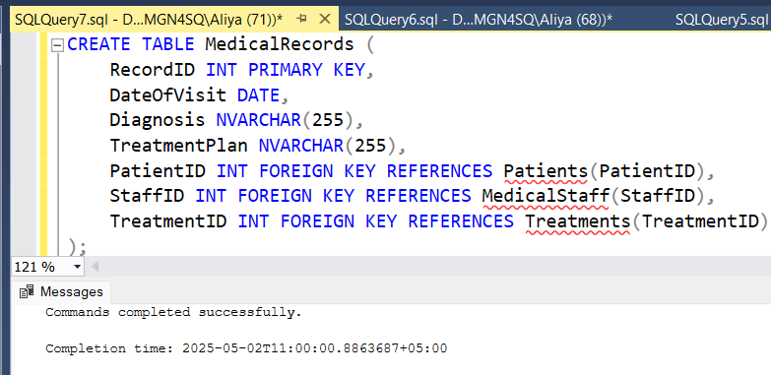
TASK 2 INSERTING DATA
SYNTAX OF INSERTING DATA IN TABLE:
INSERT INTO tablename (column1, column2) VALUES ('value1', 'value2');

- Patients Table
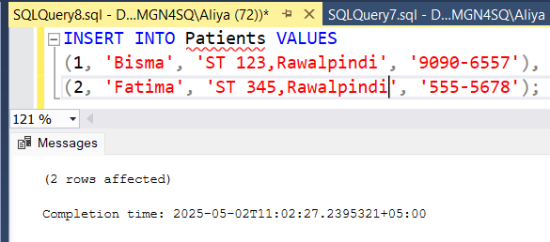
RESULT
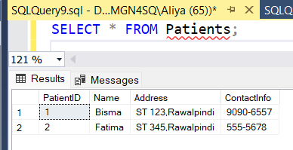
- Medical Staff
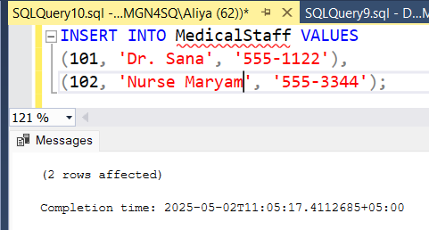
RESULT
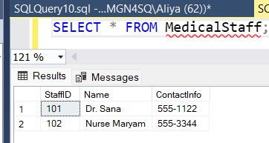
- Treatments Table
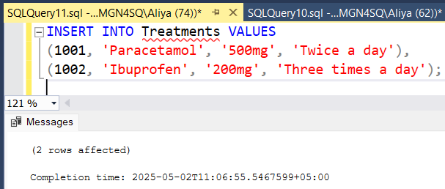
RESULT
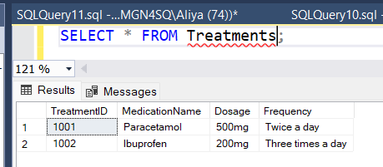
- Medical Record Table
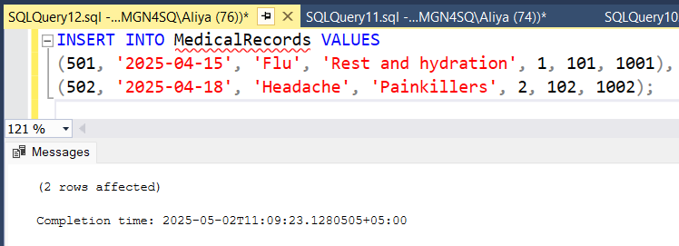
RESULT
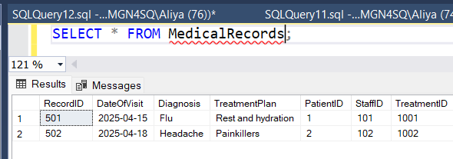

TASK 3 RETRIEVE DATA FROM TABLES
SYNTAX OF RETRIVAL OF DATA:
SELECT column1, column2 FROM tablename;
- All Patients

- Medical Records for PatientID 1
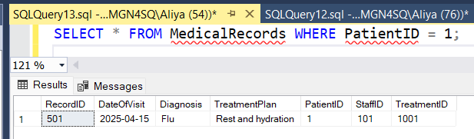
TASK 5 UPDATE QUERIES
SYNTAX OF UPDATE THE TABLE:
UPDATE tablename SET column1 = 'value1' WHERE condition;
- Update Address in Patient Table
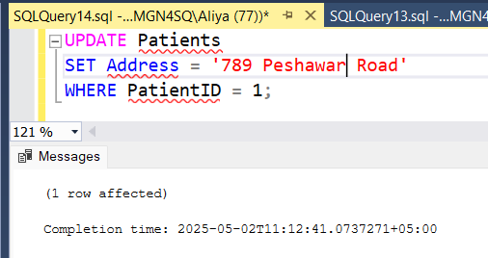
RESULT
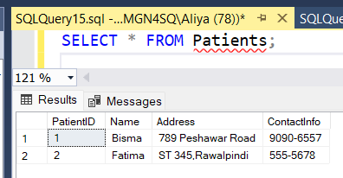

- Update Frequency in Treatments Table
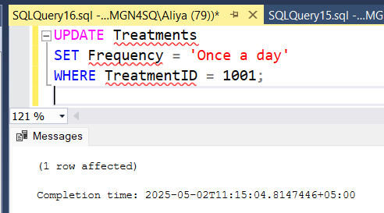
RESULT
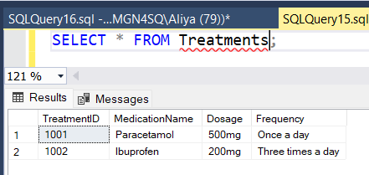

TASK 6 DELETE QUERIES
SYNTAX OF DELETING RECORD:
DELETE FROM tablename WHERE condition;
- Delete Medical Record with RecordID
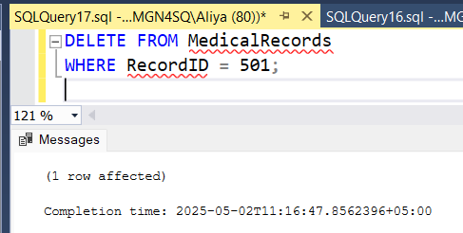
RESULT
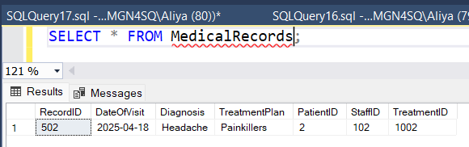
- Delete MedicalRecords Table
